SCHOOL OF COMPUTER SCIENCE AND ARTIFICIAL INTELLIGENCE |  |  |  |  | DEPARTMENT OF COMPUTER SCIENCE ENGINEERING
Program Name:B. Tech |  |  |  | Assignment Type: Lab |  |  | Academic Year:2025-2026
Course Coordinator Name |  |  |  | Dr. Rishabh Mittal
Instructor(s)Name |  |  |  | Mr. S Naresh Kumar  Ms. B. Swathi  Dr. Sasanko Shekhar Gantayat  Mr. Md Sallauddin  Dr. Mathivanan  Mr. Y Srikanth  Ms. N Shilpa  Dr. Rishabh Mittal (Coordinator)  Dr. R. Prashant Kumar  Mr. Ankushavali MD  Mr. B Viswanath  Ms. Sujitha Reddy  Ms. A. Anitha  Ms. M.Madhuri  Ms. Katherashala Swetha  Ms. Velpula sumalatha  Mr. Bingi Raju  Mr. G. Kranthi
Course Code |  |  | 23CS002PC304 | Course Title |  | AI Assisted Coding
Year/Sem |  |  | III/I | Regulation |  | R23
Date and Day  of Assignment |  |  | Week 9 - Thursday | Time(s) |  | 23CSBTB01 To 23CSBTB52
Duration |  |  | 2 Hours | Applicable to  Batches |  | All Batches
AssignmentNumber:18.4 (Present assignment number)/24(Total number of assignments)
 | Q.No. | Question |  |  |  |  |  | ExpectedTime  to complete
 | 1 | Lab 18: API Integration: Connecting to External Services with Error Handling  Lab Objectives  - Learn how to integrate Python programs with external REST APIs.  - Understand API request/response handling using requests or similar libraries.  - Implement proper error handling for failed API calls (timeouts, invalid responses, rate limits).  - Practice extracting and displaying meaningful information from API responses.  Learning Outcome  After completing this assignment, students will be able to:  - Integrate external REST APIs using AI-assisted Python scripting.  - Implement structured error handling for API failures and invalid inputs.  - Safely parse and validate JSON responses from external services.  - Develop resilient applications capable of handling real-world API limitations. |  |  |  |  |  | Week 9

Task 1 – Movie Database API Integration

Scenario
You are building a movie recommendation tool that fetches movie details from a public Movie Database API.

Task
Use AI to generate a Python script that connects to a Movie API and retrieves movie information by title.

Instructions
- Use requests library to fetch movie details.
- Accept movie title as user input.
- Display:
  - Title
  - Release year
  - Rating
  - Plot summary
- Implement error handling for:
  - Invalid movie name
  - API key errors
  - Network timeout
  - Empty API response

Expected Output
- A working Python script that fetches movie details.
- Graceful error messages instead of crashes.
- Clean, readable output format.
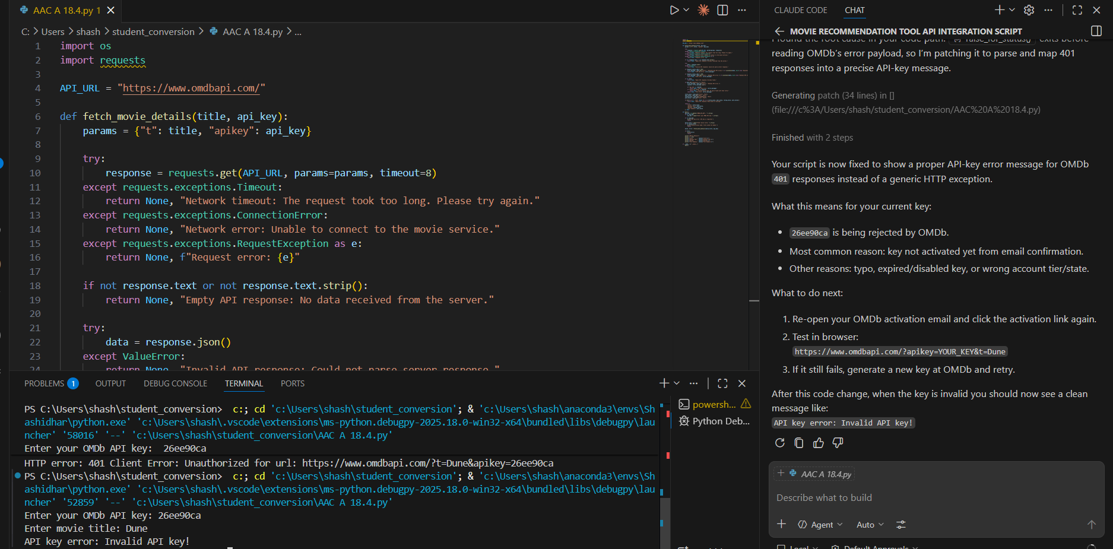
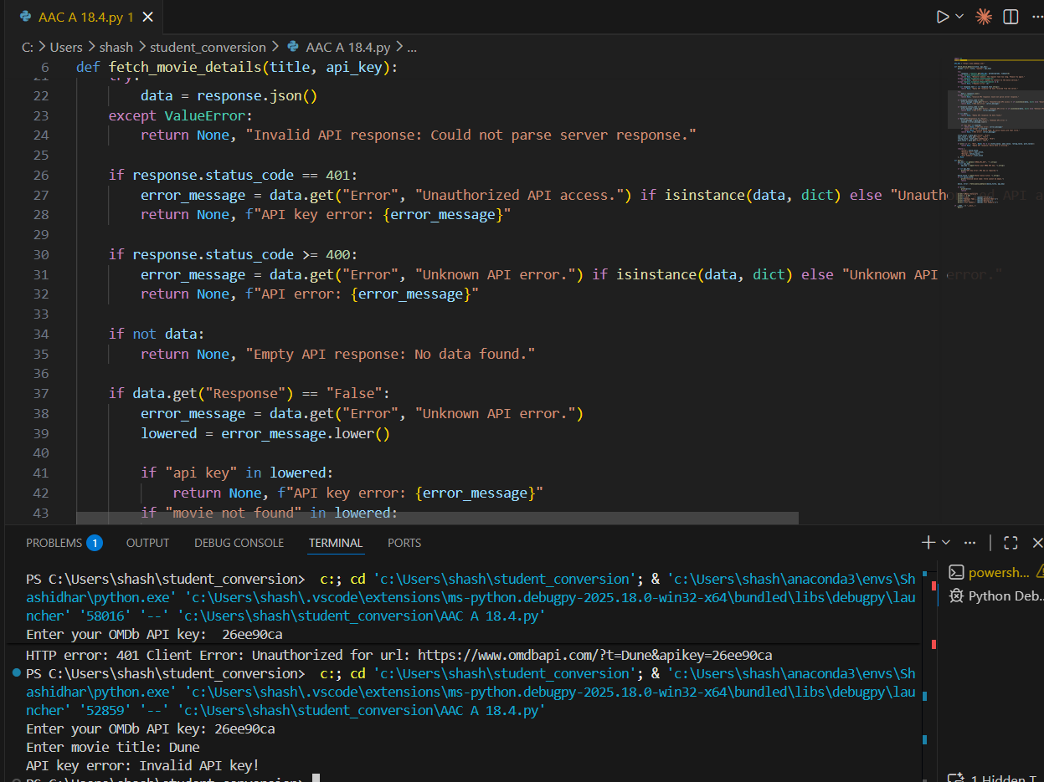

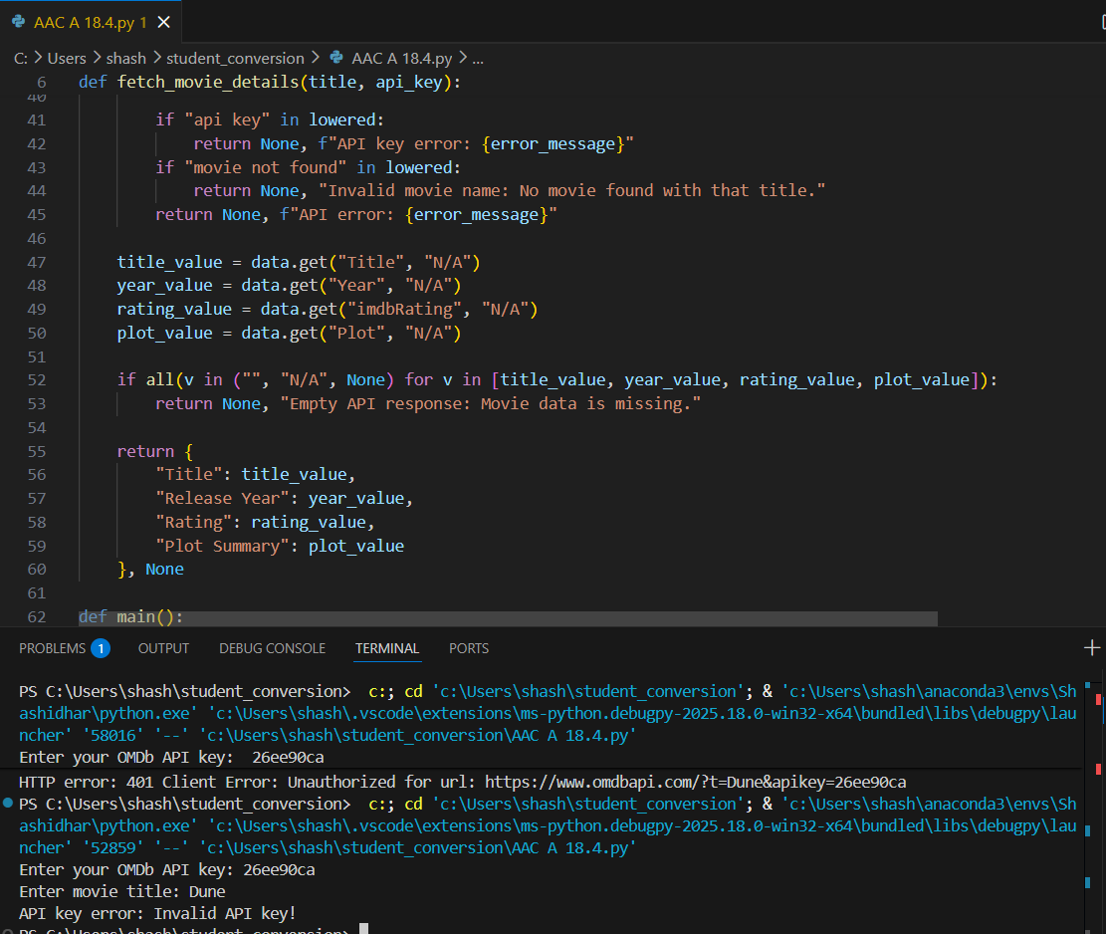

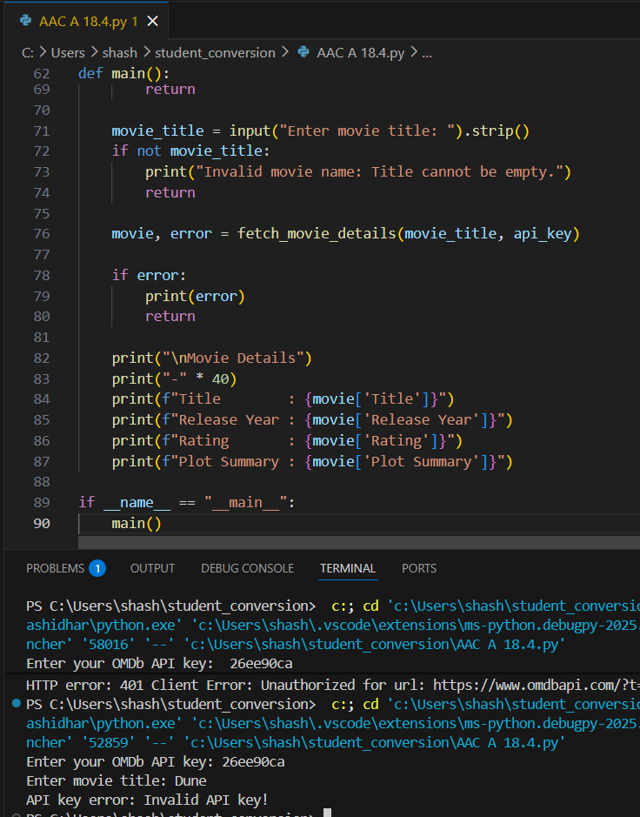

Task 2 – Public Transport Schedule API

Scenario
A city transport app needs to fetch bus/train arrival timings from a transport API.

Task
Use AI assistance to integrate a transport schedule API.

Instructions
- Fetch arrival times for a given station/stop ID.
- Validate user input.
- Handle errors such as:
  - Invalid stop ID
  - Server unavailable
  - Timeout errors
- Display next 3 arrival times in formatted output.
- Implement retry logic (minimum 1 retry attempt).

Expected Output
- Python script showing upcoming arrivals.
- Retry mechanism working properly.
- Proper exception handling using try-except blocks.
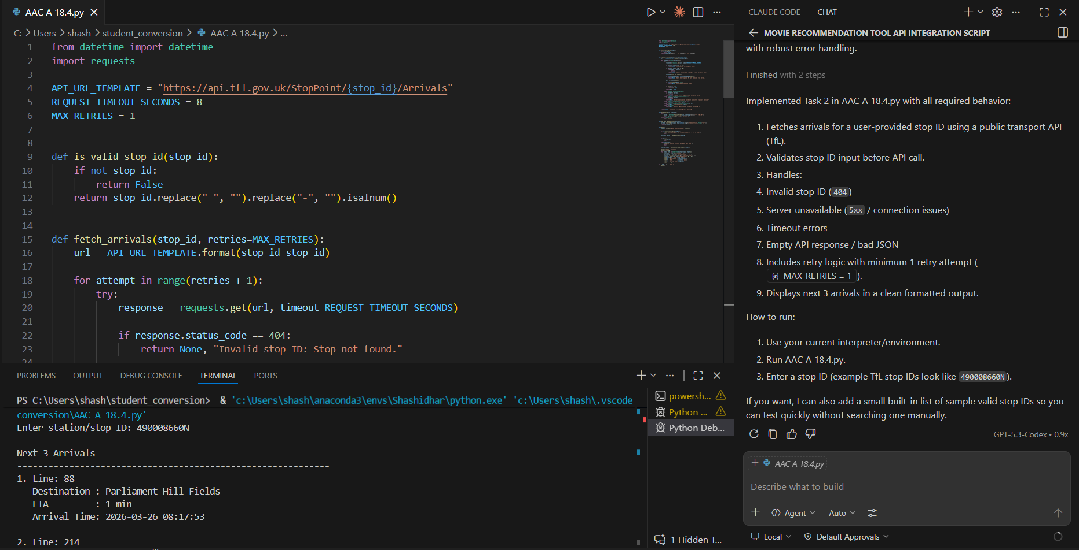
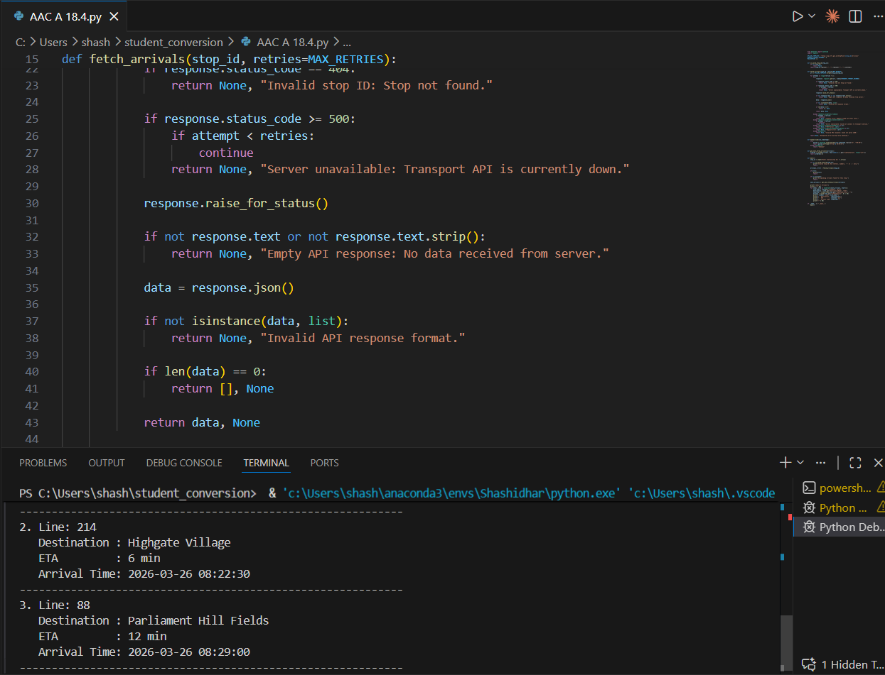
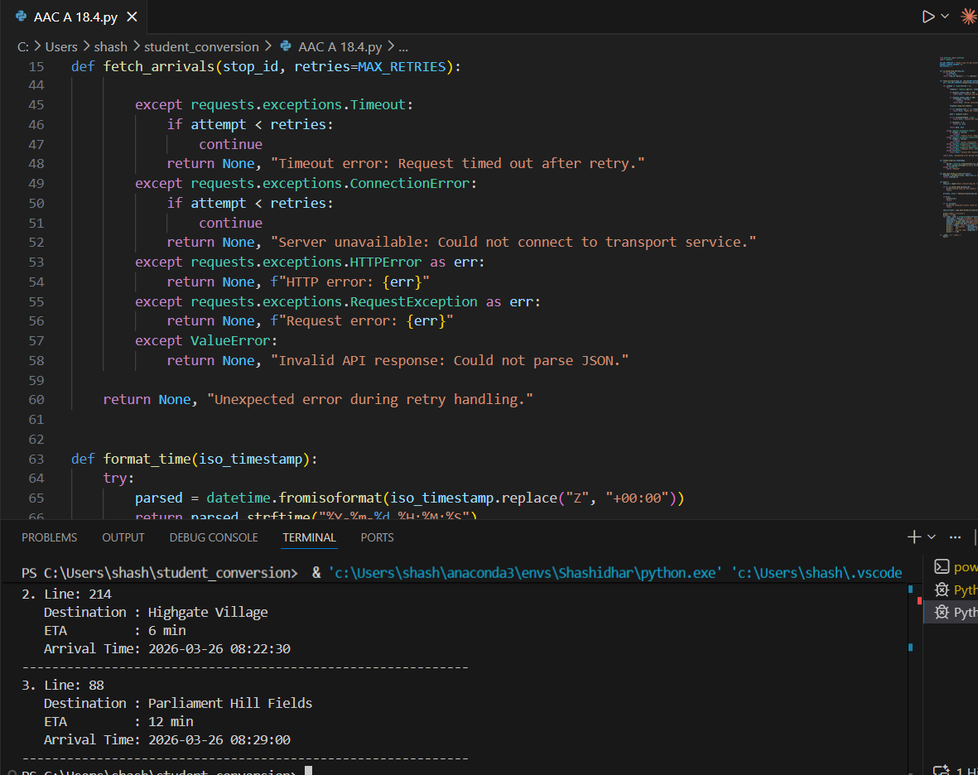
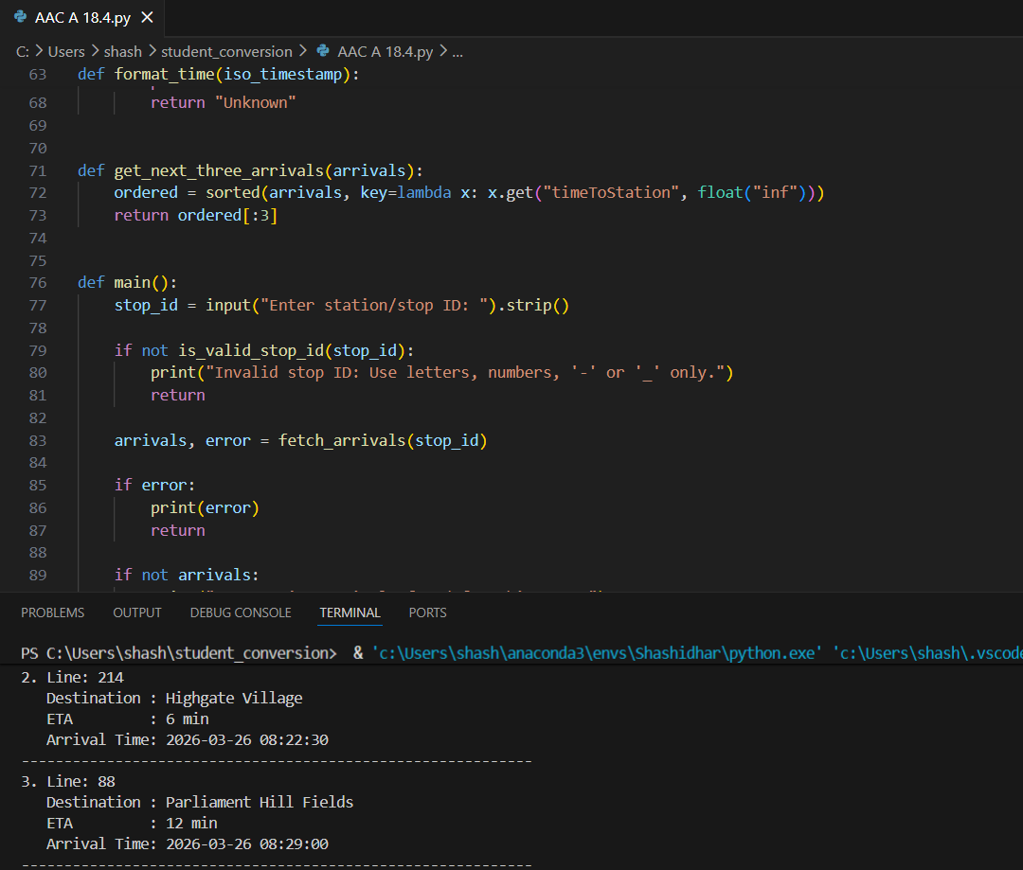
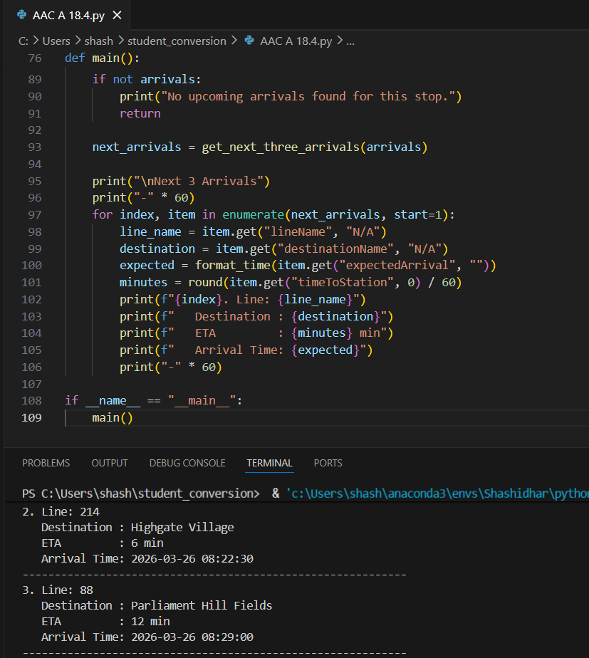

Task 3 – Stock Market Data API

Scenario
You are developing a finance dashboard that retrieves live stock prices.

Task
Use AI to generate a Python script that fetches stock data from a financial API.

Instructions
- Accept stock symbol as input.
- Retrieve:
  - Current price
  - Day high
  - Day low
- Handle:
  - Invalid stock symbol
  - API rate limits
  - Missing fields in JSON response
- Validate and safely parse JSON response.

Expected Output
- Script fetches and displays stock information.
- No unhandled exceptions.
- Clear error messages for invalid symbols or rate limits.
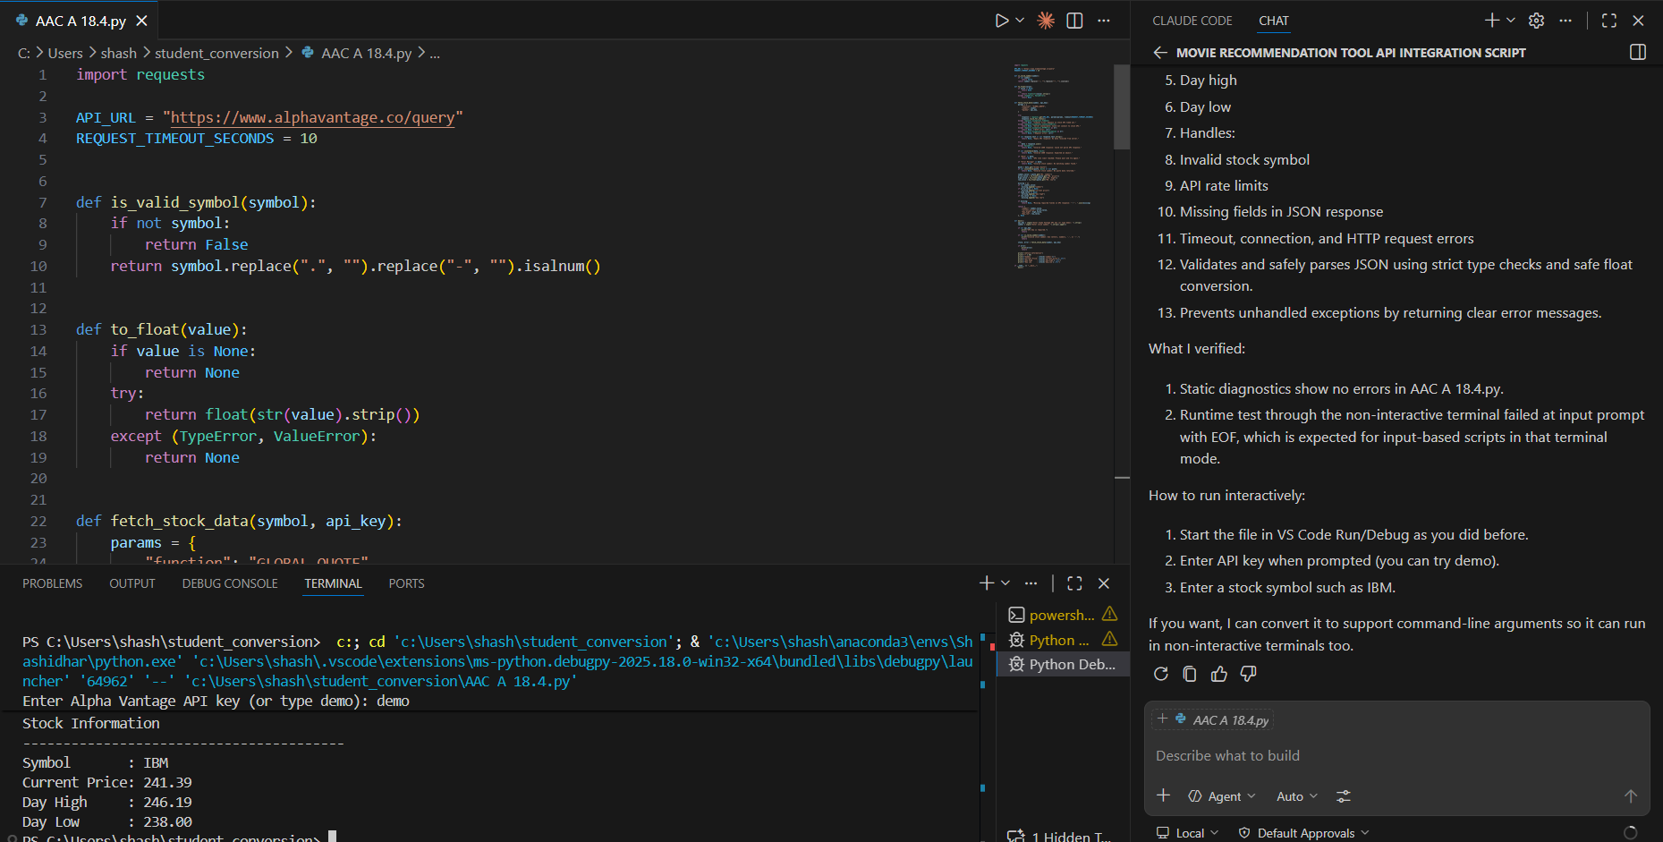
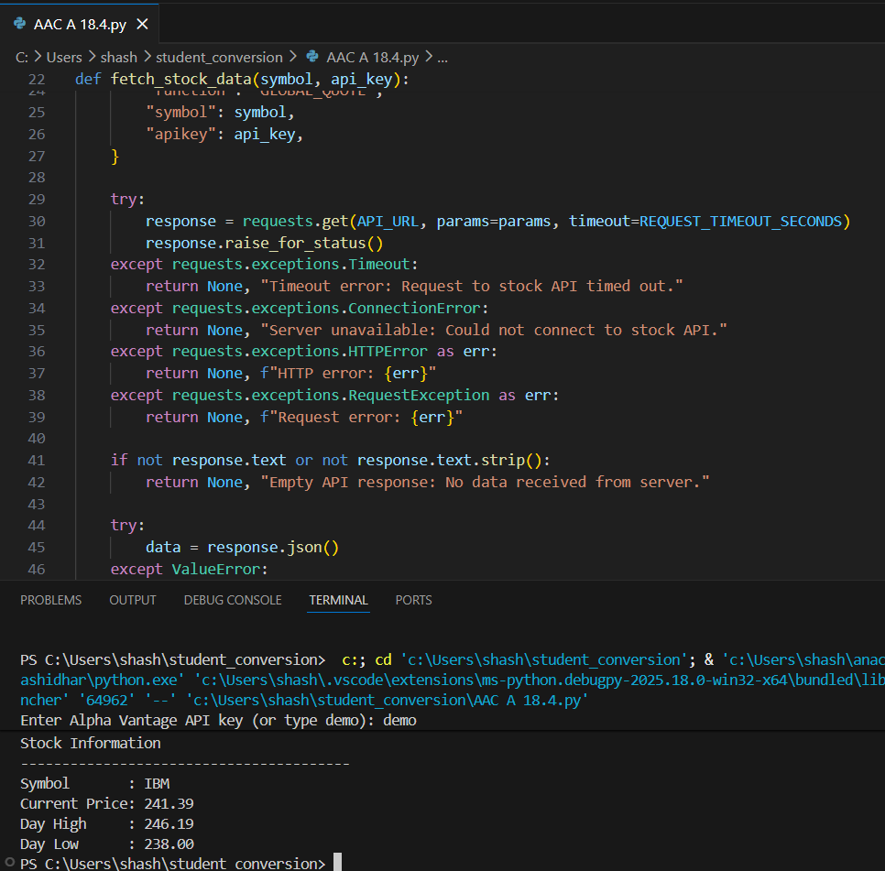
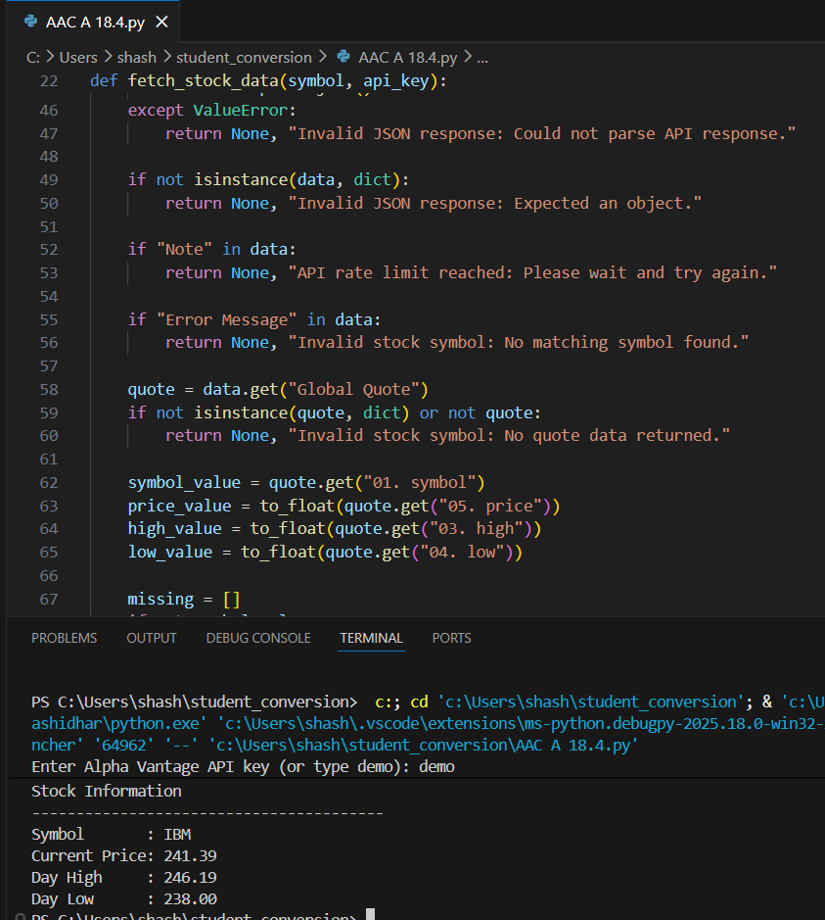
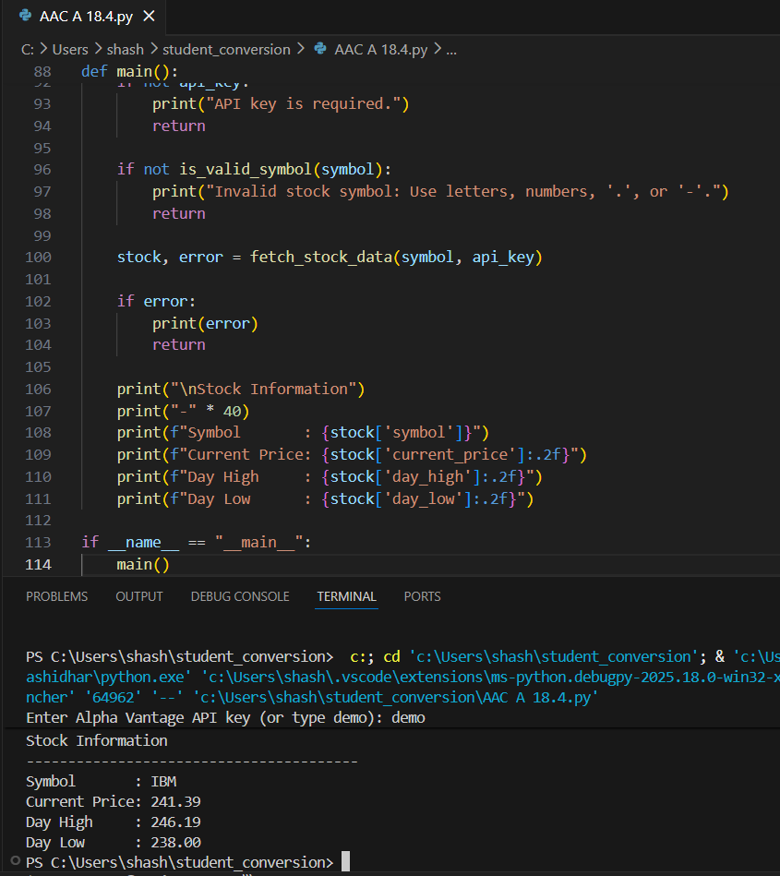

Task 4 – Geolocation API (IP Address Lookup)

Scenario
A cybersecurity tool needs to detect the geographical location of a user based on IP address.

Task
Integrate a Geolocation API using AI assistance.

Instructions
- Accept IP address as input.
- Fetch:
  - Country
  - City
  - ISP
- Validate IP format before making API call.
- Handle:
  - Invalid IP format
  - API failure
  - JSON decoding errors

Expected Output
- A script that returns geolocation details.
- Input validation implemented.
- Robust error handling included.
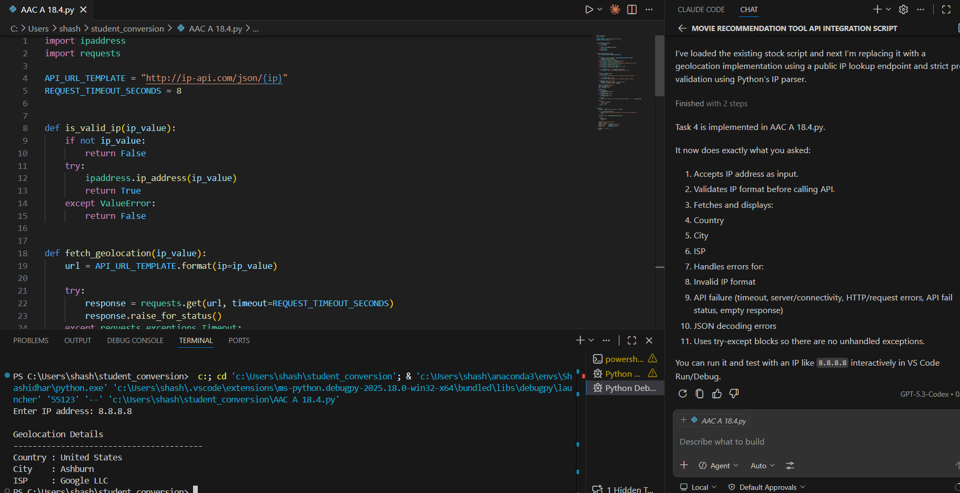
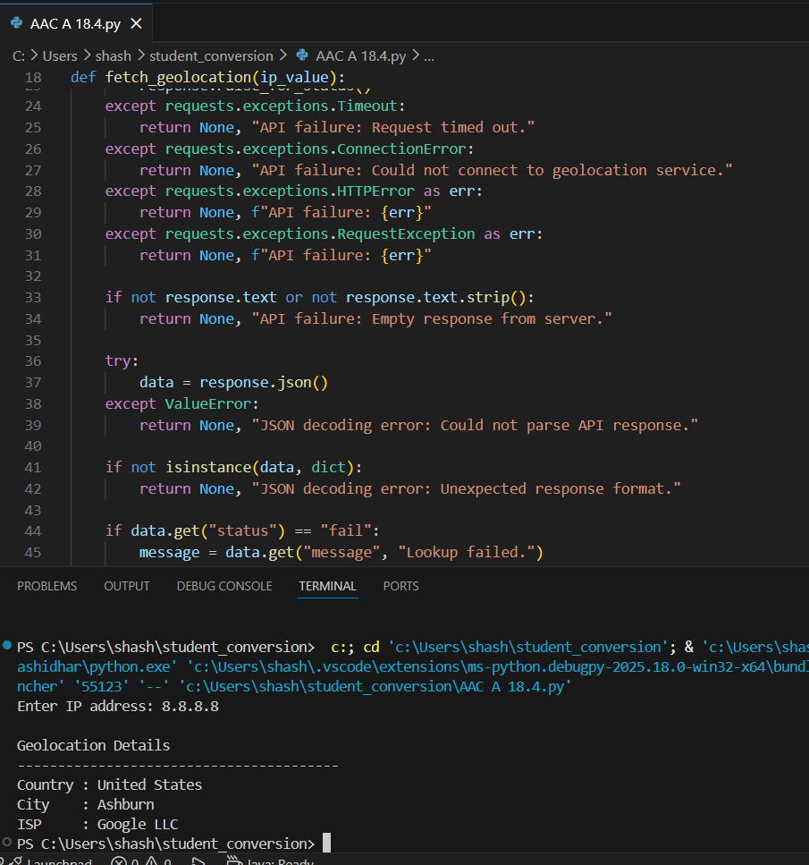
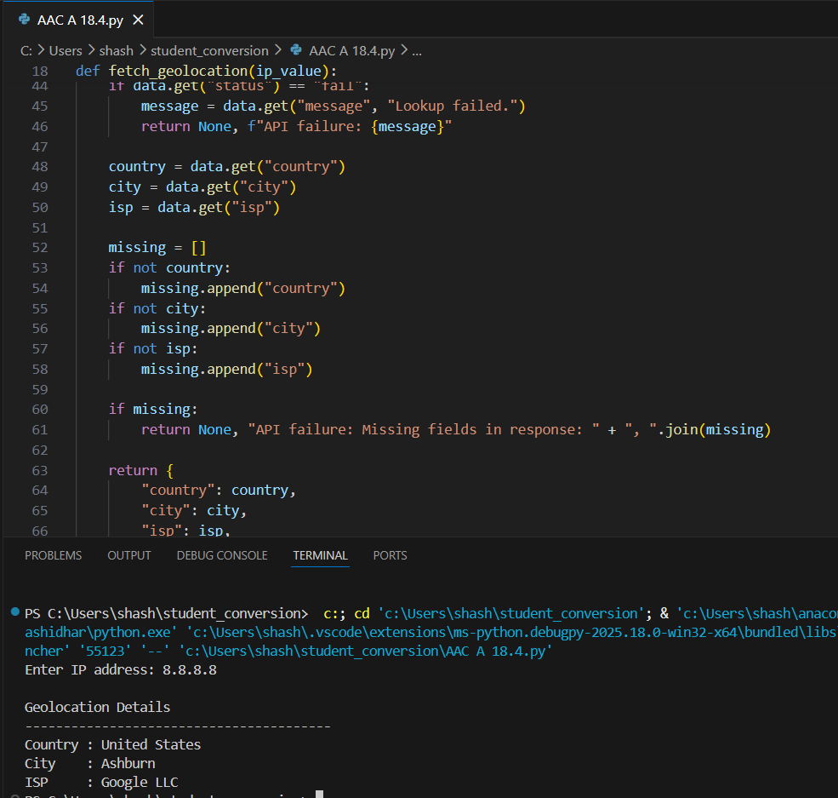
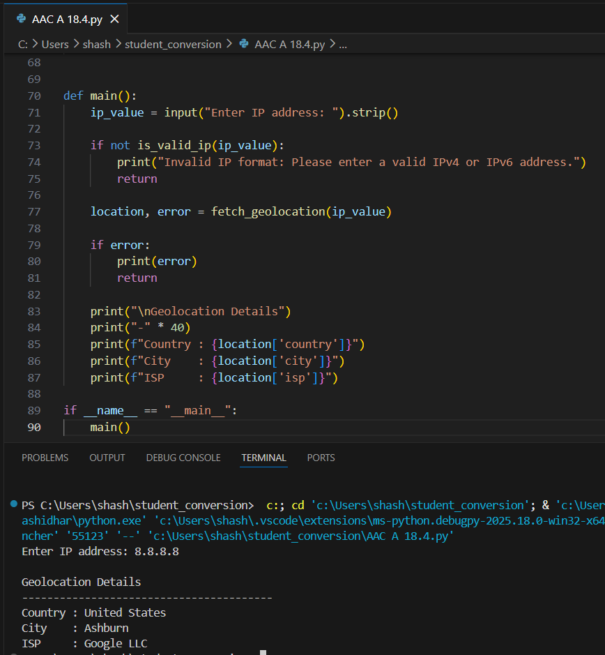

Task 5 – Real-Time Application: Payment Gateway Simulation API

Scenario
You are building a test payment integration system that connects to a sandbox payment API.

Task
Use AI to generate a Python script that simulates payment processing.

Instructions
- Send POST request with:
  - Amount
  - Currency
  - Payment method
- Validate input values.
- Handle:
  - Invalid payment details
  - HTTP status errors (400, 401, 500)
  - Network interruptions
- Display transaction status clearly.
- Log failed transactions to a file.

Expected Output
- Script processes simulated payment.
- Errors handled gracefully.
- Failed requests logged properly.
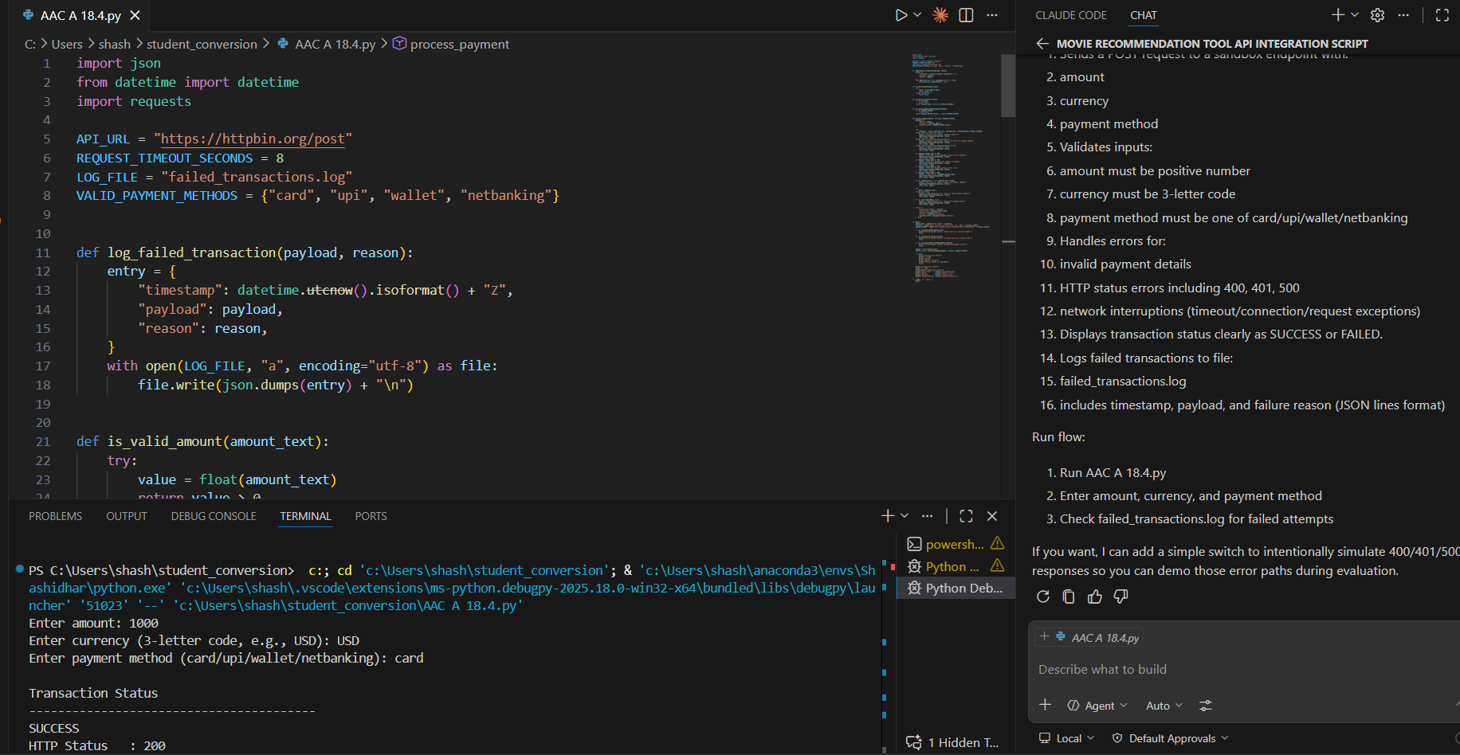
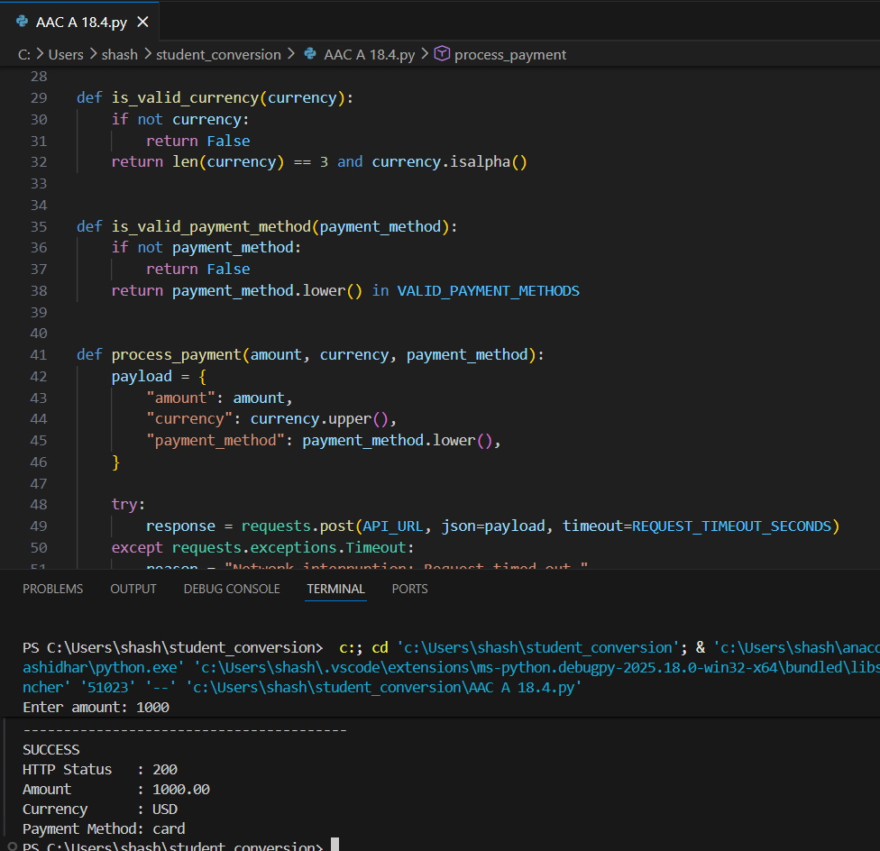

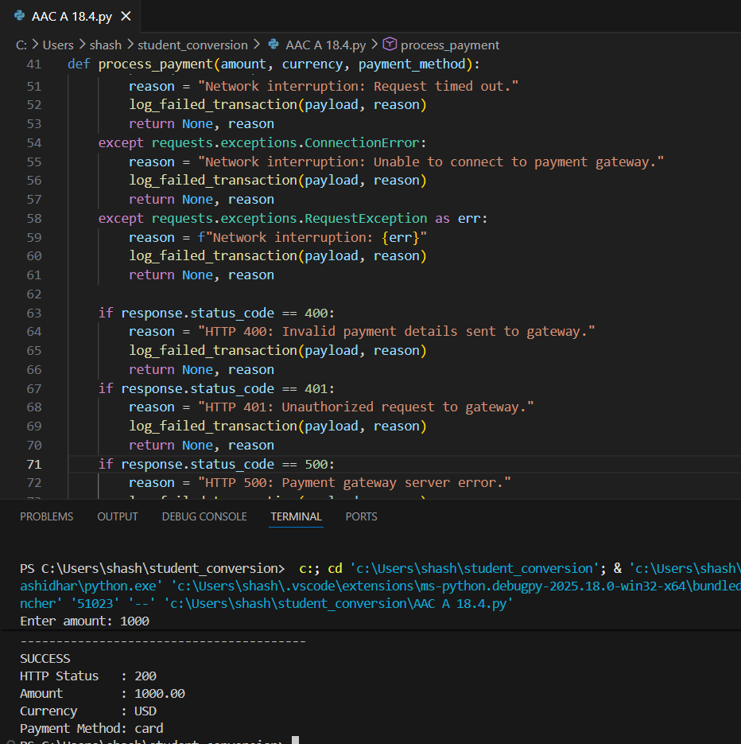

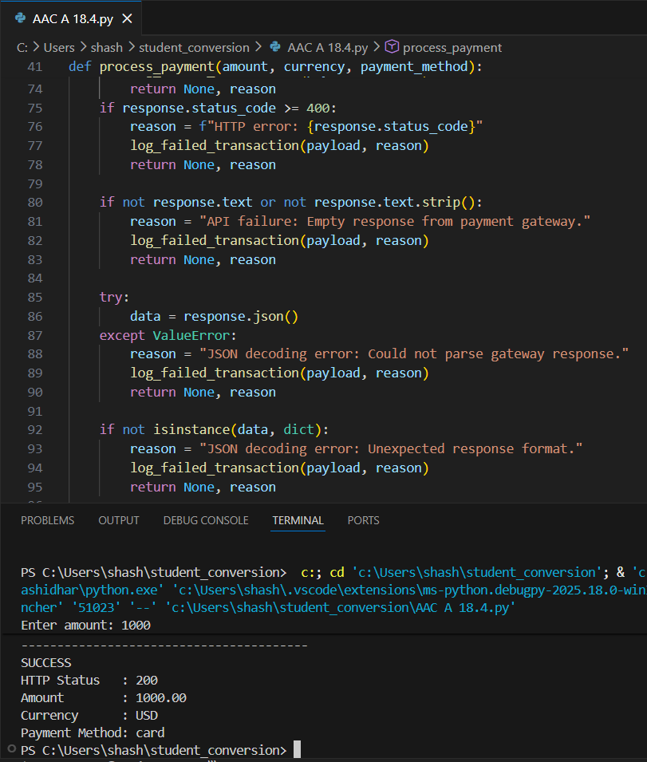

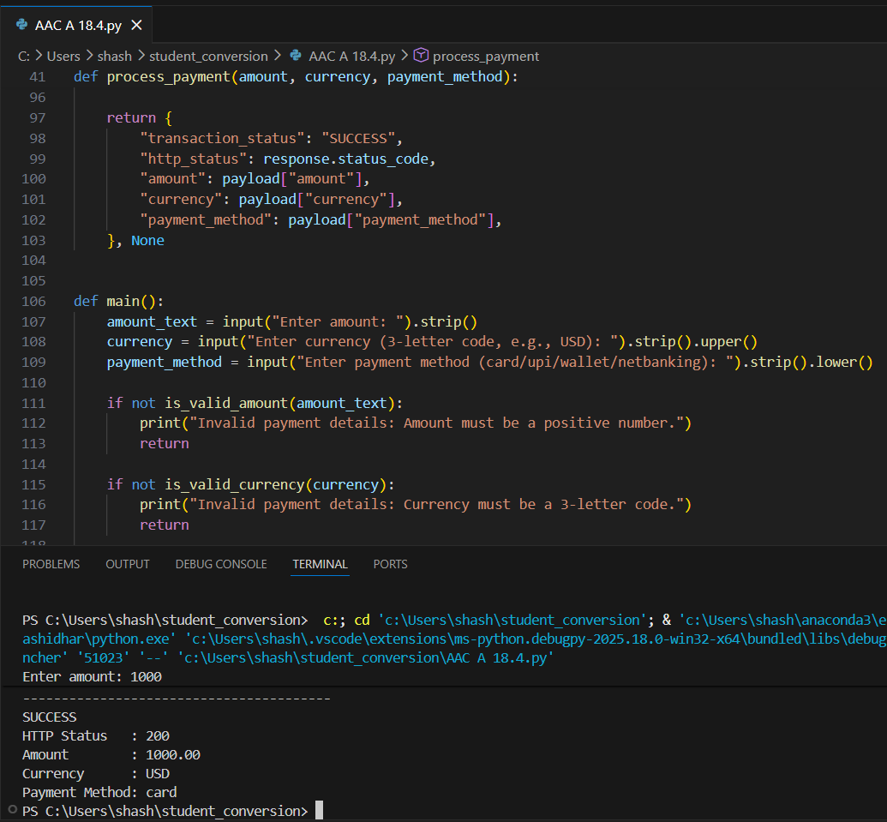

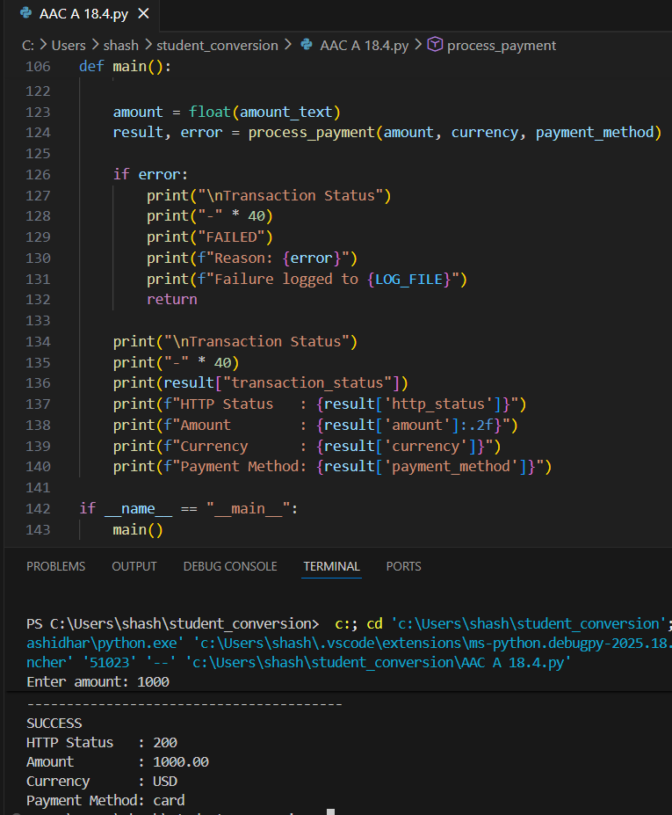

Note: Report should be submitted a word document for all tasks in a single document with prompts, comments & code explanation, and output and if required, screenshots

